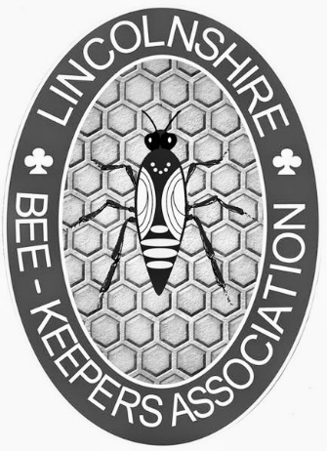
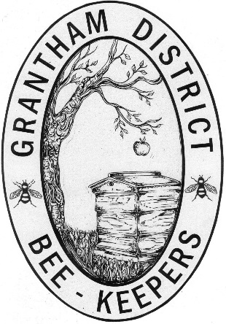
Classes of Membership in Lincolnshire Beekeepers' Association (Reg. Charity no. 500360)
Grantham District

1. Full Member: £30.00
An active beekeeper or someone wishing to be treated as such becomes a member of the local District, Lincolnshire Beekeepers' Association (LBKA) and British Beekeepers' Association (BBKA). As a Registered member of BBKA:
- Receive BBKA News magazine monthly.
- Attend BBKA events
- Product and Public liability insurances to £10 million
- From BDI, brood disease insurance for the first 3 colonies (additional premiums for more than 3; £2 for 2 extra, £5.25 for 7 extra, £7.75 for 12 extra, £9.50 for 17 extra, £11.10 for 22 extra, £13.60 for 27 extra)
As a voting member of LBKA:
- Attend LBKA events at Association and District level

2. Partner Member: £20.00
A member who is an active beekeeper with rights as above except that they share BBKA and LBKA publications with the Full Member who lives at the same address and the Full Member pays for any extra BDI cover.
3. Junior Member: £10.00
A beekeeper under 18. Must have adult member who acts in supervisory capacity.

4. Associate Member: £5.00
A member who is not an active beekeeper has access to all District activities and some LBKA activities at the discretion of the organisers.

5. Country Member: £15.00
An Associate Member (i.e. non- beekeeper) who wishes to opt into BBKA. Receives BBKA News but does not receive any of the BBKA insurances.
Membership runs from 1st Jan to 31st Dec but new members joining after 1st Sept have membership to the end of the following year.

Please note there is a late payment fee of £10 if renewals are not received by 31 January.

